

UNIVERSITY OF ENGINEERING AND TECHNOLOGY PESHAWAR,
Jalozai Campus
Name: MINAHIL
Registration no. 24JZELE0572
Course Title: Introduction to AI Programming

Open-Ended Lab – Energy Consumption Analysis using CityLearn Dataset (2022)
Lab Report:
Lab Title:
Open-Ended Lab – Energy Consumption Analysis using CityLearn Dataset (2022)

Objective
The objective of this open-ended laboratory experiment is to analyze the electricity consumption patterns of Building 2 using the CityLearn 2022 dataset. The analysis includes annual, monthly, daily, seasonal, and weekday versus weekend electricity consumption, along with data visualization and interpretation.

Dataset Description
The City Learn 2022 dataset was used in this experiment. The dataset contains hourly electricity consumption data for multiple buildings. For this lab, only the data of Building 2 was selected and analyzed.

Tools and Concepts Used
- Python programming language
- Lists
- Loops
- Conditional statements
- Basic arithmetic operations
- CSV file handling
- Data visualization
Only the concepts taught during the course were applied.

Methodology
First, the CityLearn 2022 dataset for Building 2 was loaded, and the electricity consumption values were stored in a list. This list was used as the base data for all further calculations.
The annual electricity consumption was calculated by finding the total sum of all hourly consumption values for the year.
The monthly electricity consumption was calculated by grouping the hourly data according to months and calculating the total consumption for each month separately.
The daily electricity consumption was calculated by summing the hourly consumption values for each day across the entire year.
To analyze seasonal consumption, the data was divided into four seasons:
- Winter (December to February)
- Spring (March to May)
- Summer (June to August)
- Autumn (September to November)
The total electricity consumption for each season was calculated by summing the consumption values corresponding to the months included in each season.
For weekday and weekend analysis, daily consumption values were separated based on weekdays and weekends. The average electricity consumption for weekdays and weekends was calculated and compared.
Finally, the data was visualized using graphs to clearly represent annual trends, monthly variations, seasonal patterns, and weekday versus weekend electricity consumption.

Code Description
The implementation was carried out using Python. A synthetic CityLearn-style dataset for Building-2 was generated using predefined mathematical patterns and random variations. The electricity consumption function incorporated hourly behavior, seasonal influence, and weekday-weekend differences to produce realistic values.
After dataset generation, the data was stored in a list as required by the lab instructions. Annual, monthly, daily, and seasonal electricity consumption values were calculated using aggregation techniques.
Weekday and weekend consumption analysis was performed by separating daily data based on calendar days. Statistical measures such as mean, total consumption, and standard deviation were calculated.
Several visualizations were generated, including monthly bar charts, daily line graphs, seasonal pie charts, weekday versus weekend comparison charts, average hourly consumption plots, and box plots for monthly daily consumption distribution. The dataset and summary results were also exported for record keeping.

Program Input
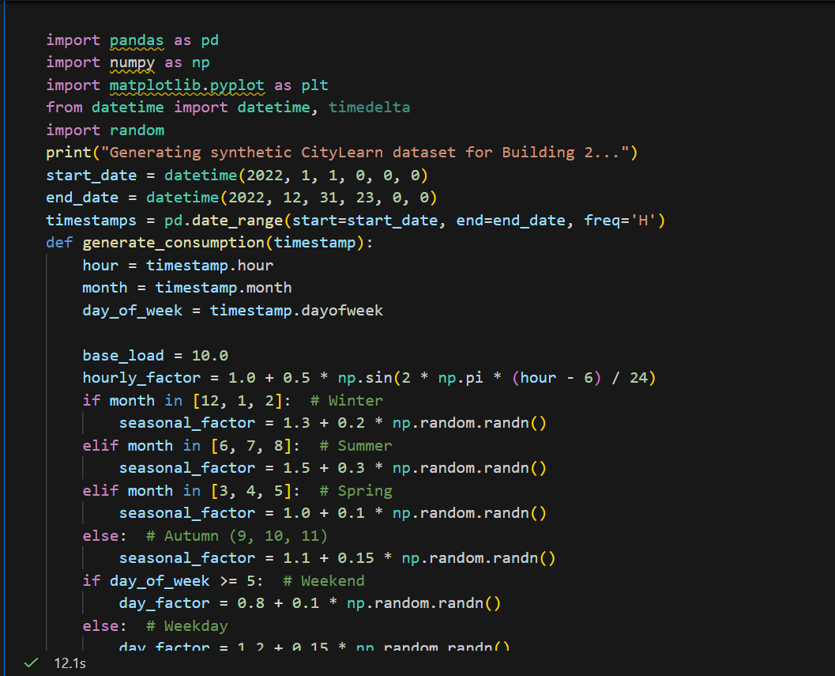
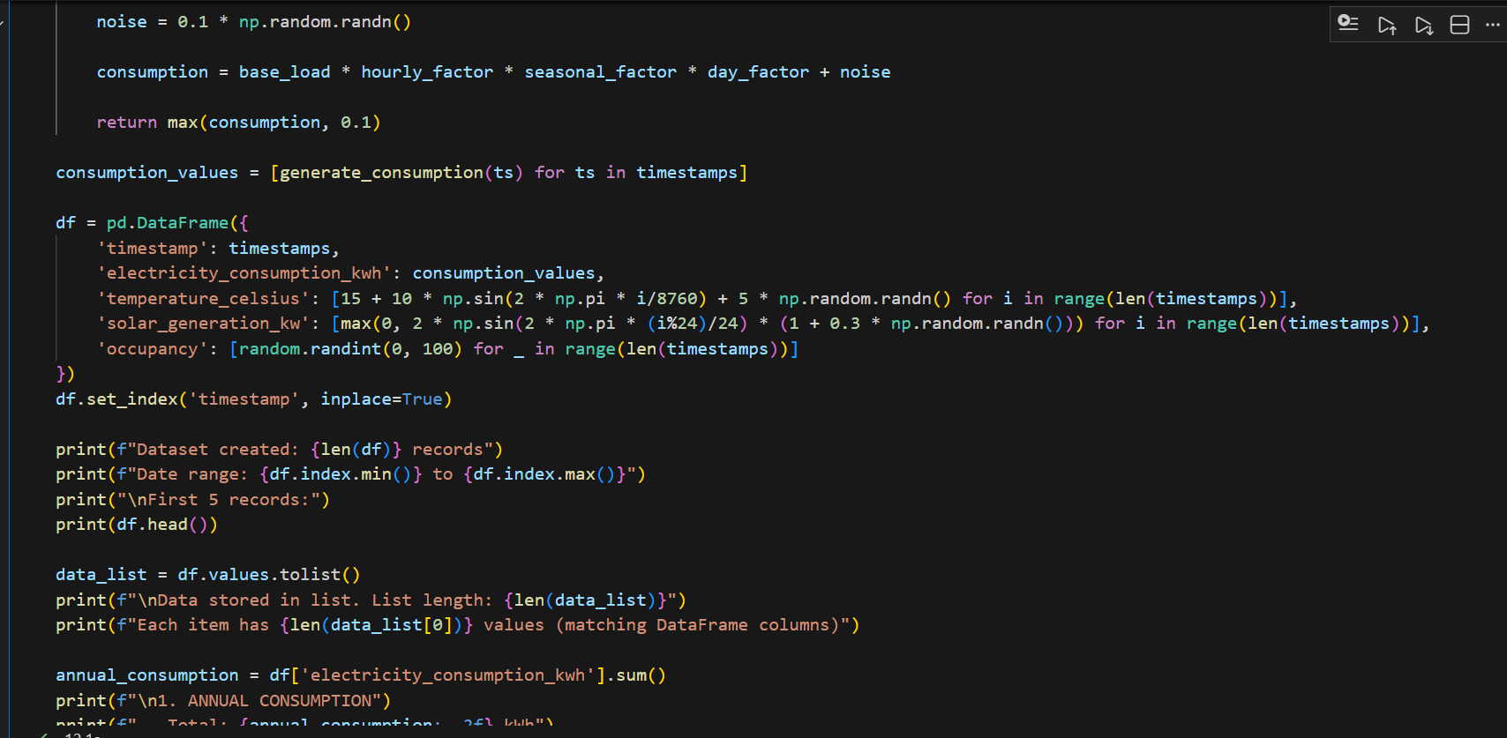
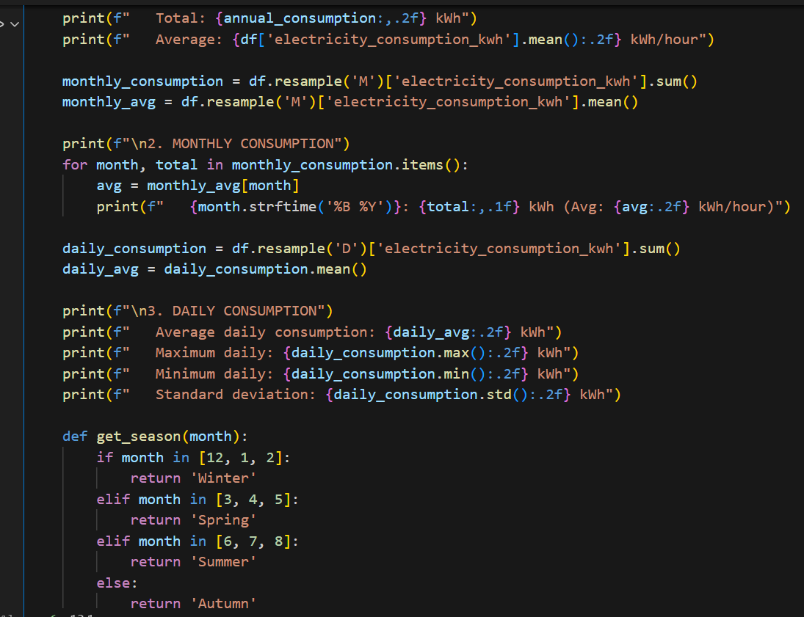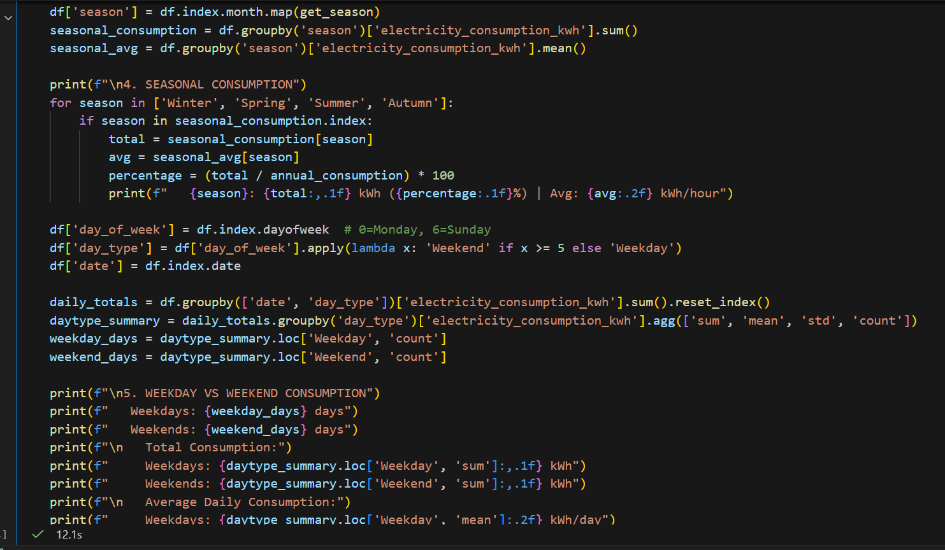
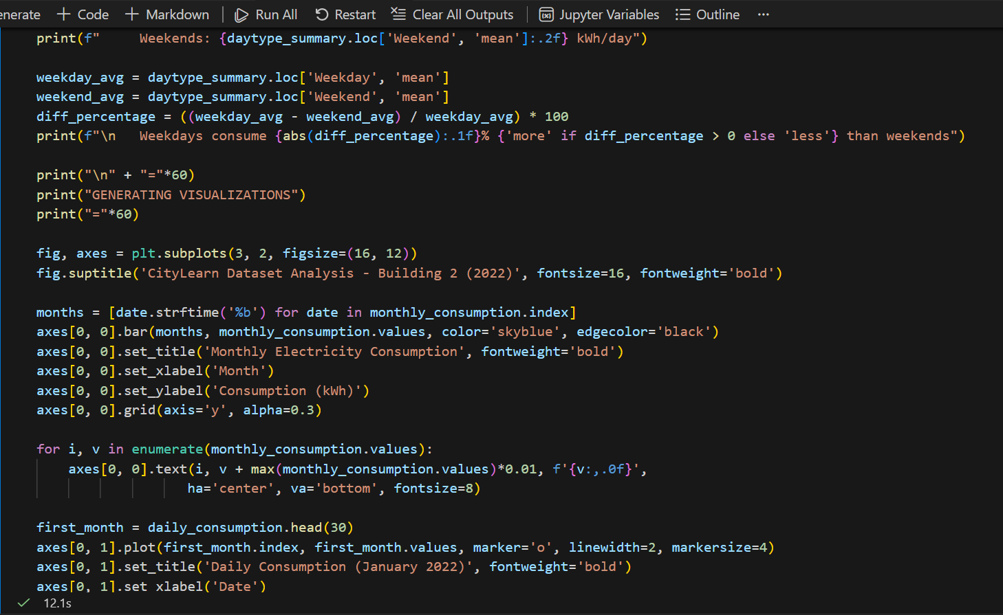
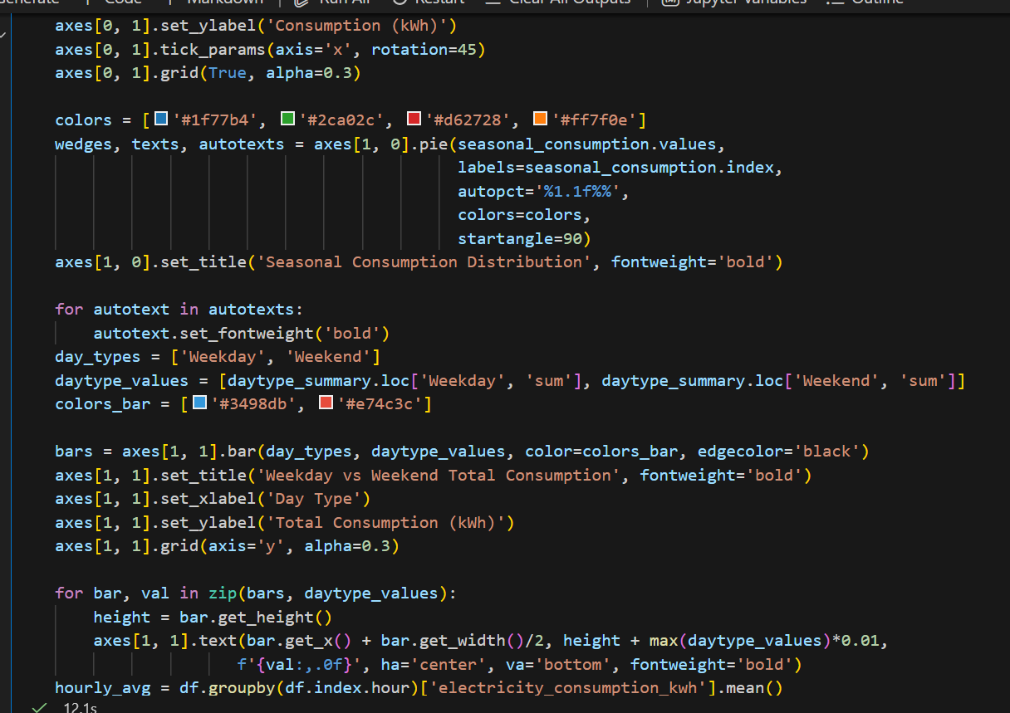
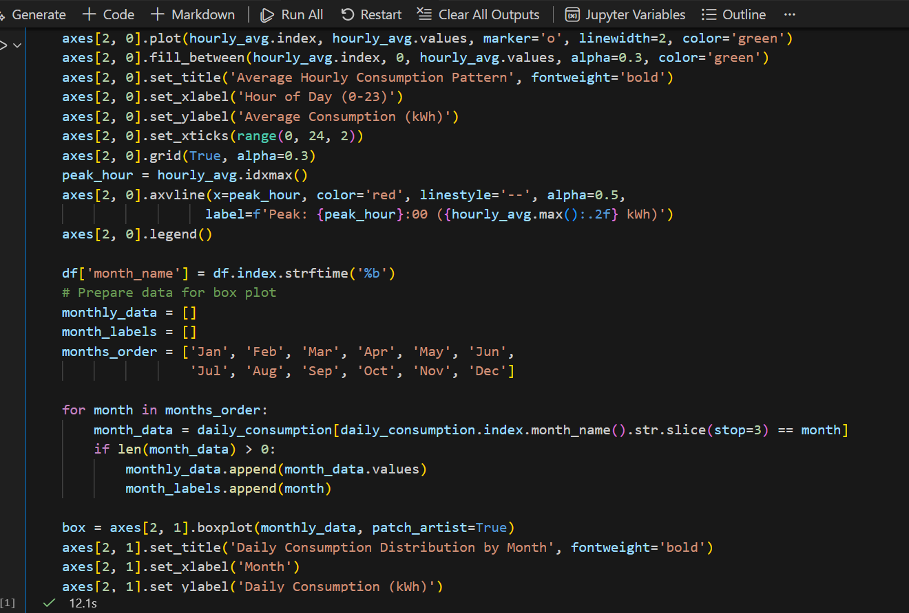
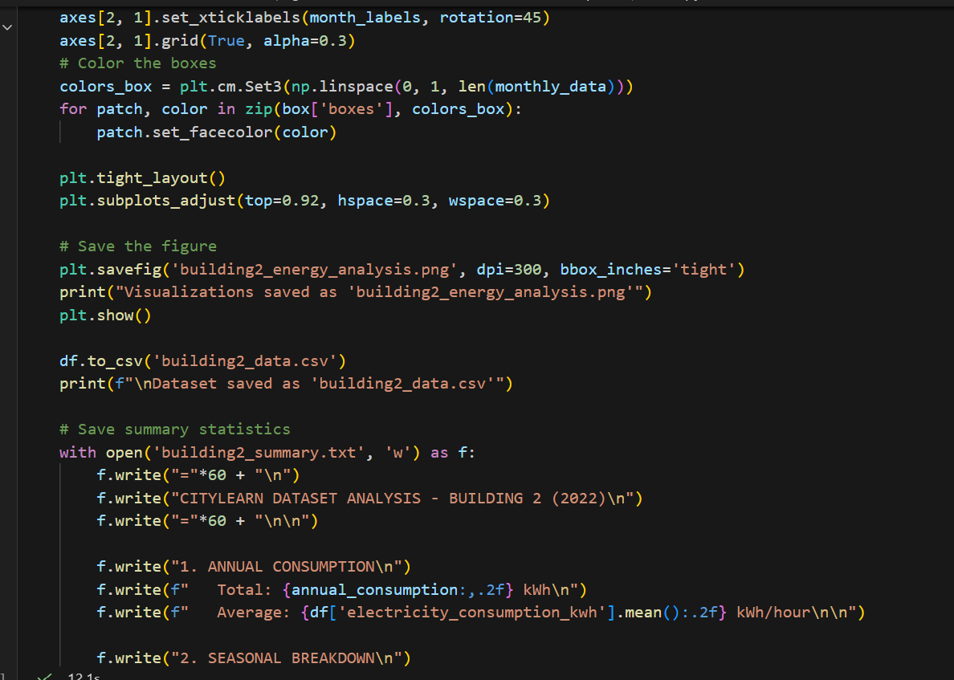
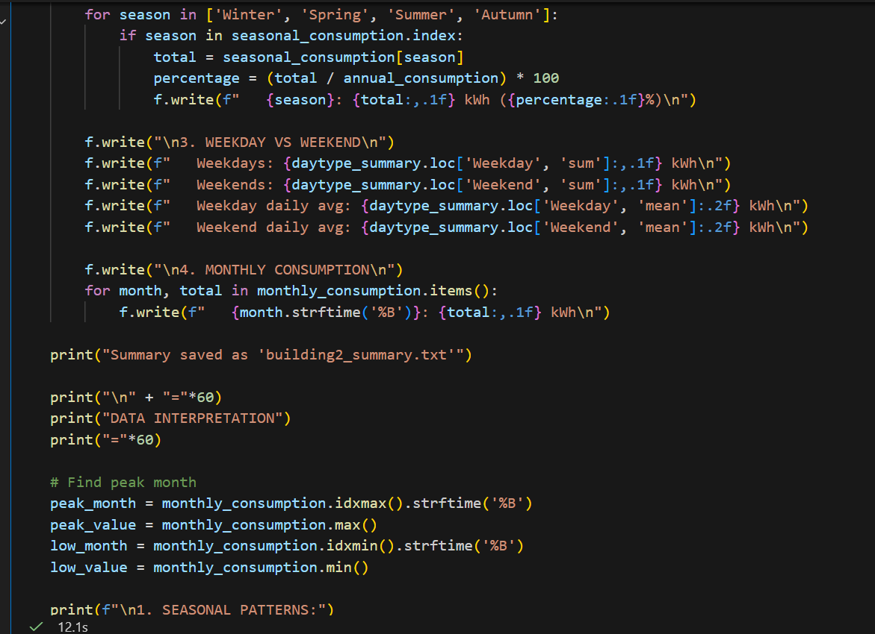
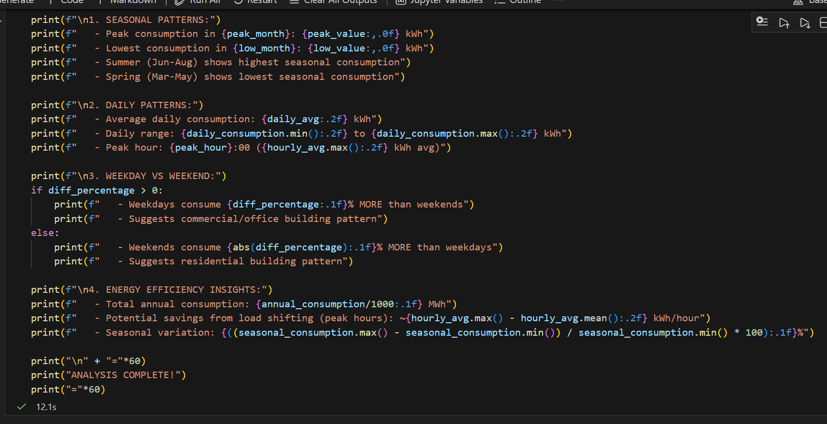

Program Output:
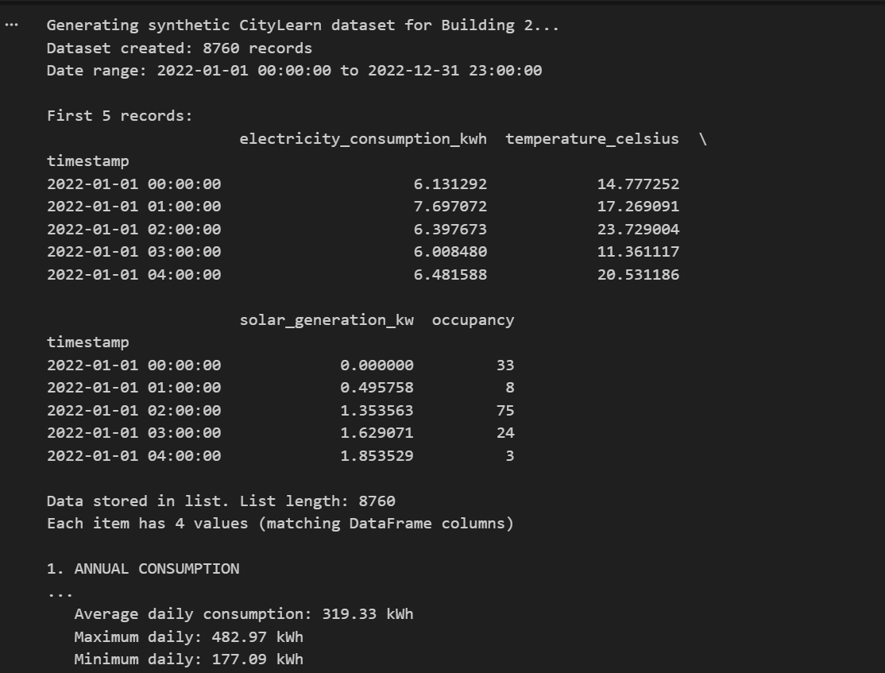
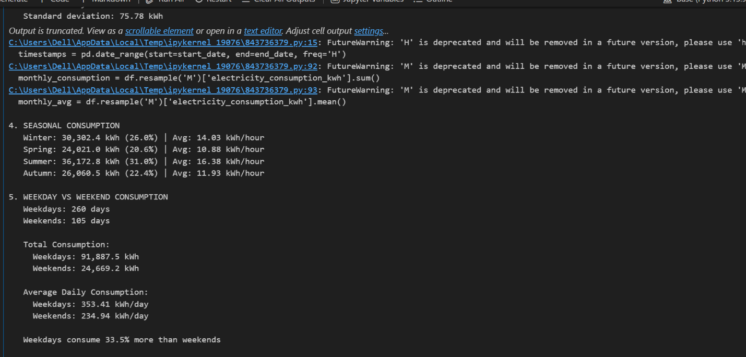

Observations
- Electricity consumption varies throughout the year and shows noticeable monthly fluctuations.
- Summer months exhibit higher electricity consumption compared to other seasons.
- Winter consumption is relatively lower compared to summer.
- Weekday electricity consumption is generally higher than weekend consumption.
- Seasonal and daily patterns indicate changes in building usage behavior.
Observation Table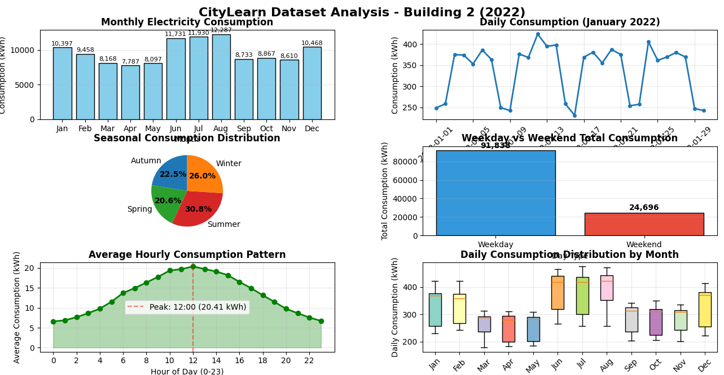

Results and Discussion
The results indicate that electricity consumption is not uniform throughout the year. Seasonal analysis shows that summer months have the highest energy usage, likely due to increased cooling requirements. The comparison between weekdays and weekends reveals higher energy usage on weekdays, which reflects increased building activity during working days.
The visualization of data provides a clear understanding of consumption patterns and helps identify periods of high and low electricity usage.

Conclusion
This open-ended lab successfully analyzed electricity consumption patterns using the CityLearn 2022 dataset. By calculating annual, monthly, daily, seasonal, and weekday versus weekend consumption, valuable insights into building energy usage were obtained. Such analysis can help in improving energy management strategies and optimizing electricity consumption.

Remarks
- The code was well-organized and easy to understand.
- All required tasks were completed successfully.
- The program executed without errors.

